**IOT Based Energy Management System**

**Business Plan**

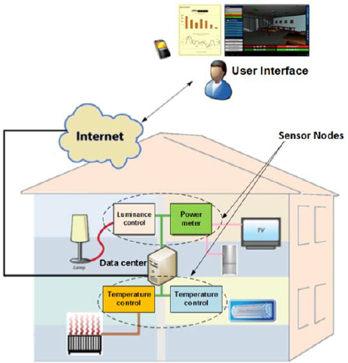

**Figure1: Adapted from[7]**

**Promoter Details**

**VimalJaswal**

**School of Informatics and Engineering**

**Address:** Barnwell, Hansfield, Dublin 15

**Telephone:** +353-894453191

**Email:** B00122875@student.itb.ie

**College Details:** Technological University Dublin, Blanchardstown Campus, Blanchardstown, Dublin

**Lecturers Name:** Cormac McMahon

**Lecturers Email:**cormac.mcmahon@itb.ie

**Executive Summary**

The Scenario of operating machines have been changed with the advancement in internet of things technologies. This led every sector to change the traditional techniques and operations. Today we see that machines can communicate to each other via internet and cloud platform. Machines of mobile size can operate other machines with a single touch that require so much effort in earlier days. Today Computers can be used as Information, Communication and Operation technology devices that can do all of our manual work automatically by giving programmed instructions to other machines.

Every sector has been implementing the IoT technology for fast, easy and profitable access in their business. This has provided improved efficiency and performance in various sectors such as Smart Homes, Smart Car Parking, Commercial Smart Grid systems, Chemical industry, Transport, Medical etc. The Implementation is not up to the full extent yet. But sensor-based operations and communication has improved the way of living standard efficiently than it was a couple of years ago.

In this Business Report plan I am going to suggest an IoT based Energy Management System that can help us manage all the electrical and electronic appliances and machine around us effectively via internet and cloud communication. This Business would be a combination of product and service which would require initial setup of the other machines to a common interface via which they can be monitored and controlled as per the requirement of the customer. This would enhance energy savings and efficient utilisation of the electric energy simultaneously making a balance in the need of electricity demand in the country keeping in eye on the natural environment.

There would be no requirement of more energy generation plants which are expensive for the government and other organisations. So, the idea is to manage the demand side rather than increasing the supply techniques. Its similar to saving drinking water by reducing its wastage.

Bringing the hybrid service would be a challenge as there are many competitors in the market available for commercial users. Therefore, my target would be to keep in contact the small industries and domestic consumers of electricity first for initialising business.

The start-up would require investment and external funding,So, I would circulate my plan to the Electric Companies that provide services to domestic users and industries. I would welcome other investors as well whosoever liked the idea and is interested in promoting the business to lead it to success.

Through this plan I would convince readers why IoT based energy management is required? How it would make an impact in Market? How it would grow benchmark in perfect market of other Energy Management Systems? How it would attract customers and the financial path required to grow the business through this idea.

# **1.Product or Service**

## **Introduction**

Meeting Energy requirement is one of the major challenges of today. World’s Energy demand is anticipated to grow in few years. This is due to increase in population, economy, industrial abundance in developing countries like India, China and developed countries. At the same time, it is required to reduce CO2 emissions and green house gases emissions. Energy Management in an easy, fast and quickest the solution to utilise energy effectively to tackle climate change and other issues. Energy Management is an utmost strategy for all energy consumers who are interested to reduce energy price volatility and promote green energy for climate. Consumers on demand side can play important role in this case for personal and environmental benefits.

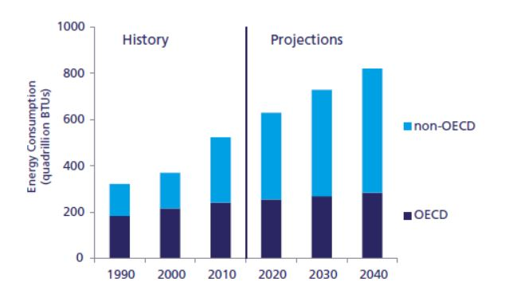

**Figure2: Historical and predicted world energy consumption of OECD(Organisation for Economic and Cooperation Development) and non-OECD countries**

**Adapted from[5]**

“Energy Management is the use of minimum energy while maintaining desired level of economic activity or service.”[5]

Today, every little operation completely depend upon electrical energy and people can’t bear the pain of its unavailability even for few hours or one day. The Service required today for energy management is not limited to only commercial sector, it can impact all sorts of customers that forms the basis of IoT based energy management.

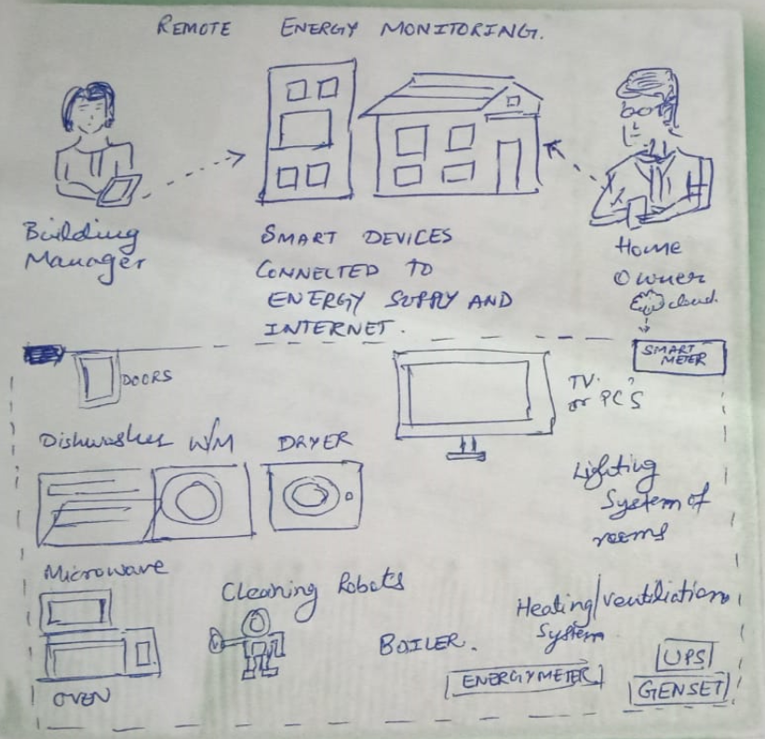

**Figure 3:Basic Sketch of Hybrid Product Service[1]**

The above napkin drawing sketch shows a basic idea how domestic customers can improve energy efficiency, operation of devices and smartly monitor the activities in their residences. The Homes are getting automated and setup with sensor-based devices. Therefore, it is necessary to easily handle operation of these devices. This would also help customers who are in sickness, old age and differently abled to easily access and control their home and its energy operation rather than manual efforts.

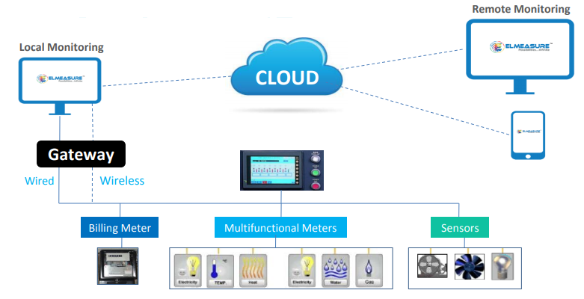

**Figure 4:Concept of IoT based Energy Management System**

**Adapted from[4]**

**Unique Attributes of my Idea:**

1. Analysis of Smart Devices and outage

2. Sustainable Energy monitor and control

3. Analysis and control over electricity consumption

**1.2 Idea Scoping**

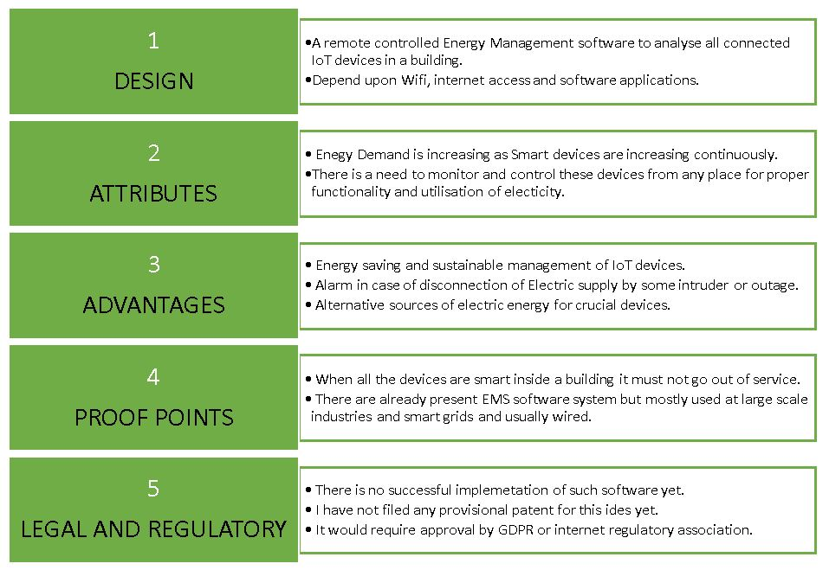

**Figure 5: Idea Scoping chart**

**Adapted from [1]**

**1.3 Customer’s Pain Statement**

* It would be a pain for customers who are using smart devices occasionally but are consuming electric power.
* Customers would require sustainable operation of all devices connected in their household and workplace.
* Smart homes and buildings must reduce traditional techniques used by customer and their effort.

**1.4 Proposed Service**

An internet of things-based Energy Management System for building with an ease to control and manage appliances and devices from a web application.

**1.5 Problem**

The number of electronic and electrical IoT enabled devices are increasing continuously which will result in increased energy usage in future and there would be rise in energy demand. Moreover, the electricity tariff will increase as well and there would be requirement of energy management everywhere. There are already a number of connected devices inside homes or buildings that require an ease of control from anywhere via a web application to reduce traditional approach of operating devices. More connected electronic devices will boom electricity bills in each household, commercial and public buildings and stations. It would be a pain for customers who are using some smart devices rarely but are consuming electric power. Moreover, the operations of these devices must be sustainable and flexible enough wirelessly to call them as smart. It is hard for people with temporary or permanent illness, disabled persons to manage devices in their home or workplace effectively. With this service they can easily operate devices via web application without any effort for example operating heating system, TV, lights, Water heaters etc.

**1.6 Services to be Offered**

* Control of all devices through web application
* Statistical and Graphical Analysis of daily and monthly usage of devices based on electricity consumption
* Estimation of monthly electricity bills based on the usage
* Monthly Energy Savings information via web application

**1.7 Plans to Develop Product/service**

**Testing Idea:** The Plan includes the development of a monitoring and controllable energy management system that can be easily implemented in homes, buildings, shops and small industries. A public opinion will be collected through a survey to improve the concept of the system so as to identify the services customer would be interested in that no other system is providing at current stage.

**Business Potential:** Based on survey further information on business analysis and competitive products and services similar to energy management systems would be gathered to figure out how these become popular and the services that are not provided or very expensive. All other information such as costs, market value, revenue and growth-related information would help drive the business idea.

**Product or Service Development:** Based on above methods carried out the hybrid service product will be designed and developed taking care of quality services and regulations. The Service will be tested in the market before massive launch. If the positive response would be more than 70% the service would be either sold for commercialisation or developed by inviting investments from government or private schemes.

**1.8 How advanced is the idea?**

Project idea will definitely get success in future as the electronic and electrical devices are being connected to internet more prominently and the count is on increase rapidly. If the Product or service will be developed successfully it will surely make benchmark in future. Internet of things applications are popular in all industries for research and development but there is no successful implementation yet.

**1.9 Work Required for Next Stage:**

For gaining success for this idea a lot of work is required and more people will be required to develop the product and bring it into service. Idea concept and business analysis will require more time to save losses in development phase. The development phase also required practical testing of service and improvements for final launch. A lot of time will be needed for advertisement as well to make people know about the service. It is more than year of work if success of the service is required.

**1.10 SWOT ANALYSIS**

The SWOT analysis gives an excellent opportunity to examine and evaluate the internal strengths and weaknesses of any business activity in its Planning phase. Hence it is necessary for Business Plan development in case of IoT based Energy Management System. It also allows us to focus on the external opportunities presented by the business environment as well as potential threats.

**1.11 Strengths**

IoT based Energy Management System has a valuable inventory of strengths that would help it to be successful. These strengths include:

a) Energy Management systems are not targeted for domestic users yet and therefore gives chance to attract customers and gives space to enter into Energy Market

b) State-of-art, energy-efficient equipment and IoT technology is new and people are required to be notified about this.

c) Clear vision of the market needs: By knowing the customer’s needs, we can be familiar with the latest technology, and we can offer the Energy Management services that would bring the two together

**1.12 Weaknesses**

a) Cost factor associated with keeping the equipment and technology

b) New business in market, competitors and challenges in spreading awareness

c) Start-up related challenges

d) limited operating capacity during peak sales periods

**1.13 Opportunities**

a) Growing applications of electrical and IoT devices

b) No competitors offer Energy Management for domestic consumers in the surrounding area Start-up Sample Business Plan

c) Consumer behaviour changes due to the economy and technology advancement

**1.14 Threats**

a) Changes in the business environment that might decrease sales

b) Higher taxes in future

c) Risk of Business Failure

Hence by using the above SWOT analysis we can countermeasure the predicted risks that can arise in case of start-up and Business Execution in practice. This would help in successful initial steps of this new business.

# **2. Marketing**

“The Global Energy Management Systems Market size is expected to reach $62.3 billion by 2023, from $25.9 billion in 2016, growing at a CAGR of 13.5% during the forecast period (2017-2023). “[7]

Energy management systems are trending because it provides competitive benefits, productivity boom, and reduction incost of energy. Furthermore, the government rules and regulationsrelated to energy conservation and the limited supply of fossils is seeking attention of the energy market investors.

The industrial energy management systems contributed maximum revenue share in 2016 due to increasingproclivity forgetting energy efficient services. Additionally, the increasing trend of energy management solutions among different market verticals has also boomed the penetration in market in past few years. Thisculturewill grow expectedly in the next years as well. The consciousness for energy management across residential users is expected to see attractive growth rate and effectivelyseek expansion of business for the market players in home EMS solutions and services. Furthermore, increasing demand of energy efficient solutions among end-users such as enterprise, office spaces, and commercial is also projected to force the market extension of the building EMS solutions.

## **2.1 Market research**

The target market that the business will want to focus on during its start-up stage is the homes. The target market includes the thousands of homes that are currently electrified. The business should also consider targeting homes that are going to be built on the reservation in the near future. The business should have a plan to market services to the companies that are planning to build these new homes. This creates a demand potential that should be a part of the target market.

After that the product can be brought to small buildings and small-scale industries as they have limited budget for buying expensive energy management system services. So, the market will go on increase once advertised properly in the market with outstanding features of energy management, device control, customer service and savings for customers.

The demand will rise in market as the generation is moving toward cloud computing and services and people want quickest way to operate and utilise machinery and moving towards a fast-paced internet-based services.

**2.2 Market size & segmentation**

The energy management systems market segment depends upon services, benefits schemes, devices, offerings, type, end customer, market region and approach.

The offerings segment is separated as systems and services. Service segment dominated the market revenue in 2016, due to its huge scope of application in commercial operations.

The services market is segmented as monitoring, control, integration, implementation, maintenance, training and consultants. [7]

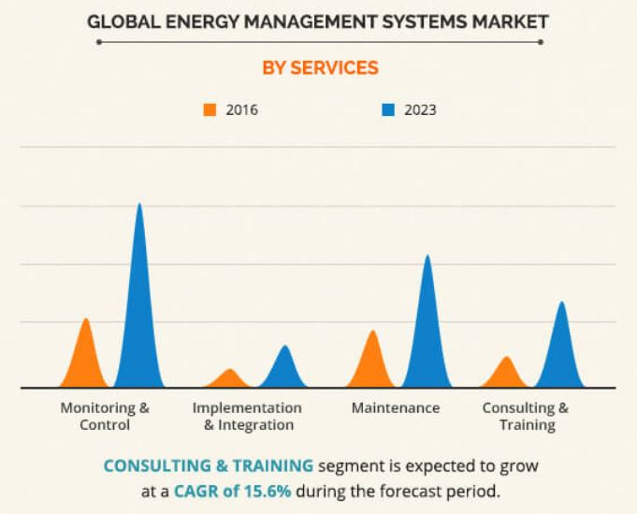

**Figure 6: Adapted from[6]**

Market Segment according to Type:

* Domestic energy management systems
* Building energy management systems
* Commercial energy management systems

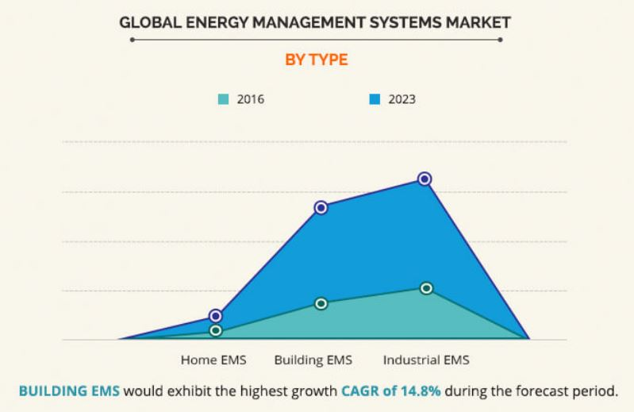

**Figure 7: Adapted from [6]**

Based on devices, the energy market is segmented via devices in trend such as sensors, controllers, software, and others. The end-user customer is divided into domestic and industrial segment.

As a market upright, the market is categorised as power and energy, IT and telecom, manufacturing, business enterprise, medical and healthcare.

Regionally, the market is segmented as continents and countries.

The analyses of market prove that there are many opportunities in Energy Management solutions market. Instead,higher initial investment cost and longer payback periods is predicted to delay the growth of energy management systems market especially regional investors.

The market size can be represented as three categories:

1. Industrial/ Commercial

2. Public Sector

3. Domestic/Household

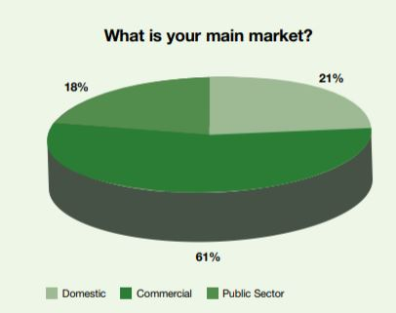

**Figure 8: Figure adapted from [3]**

**2.3 FACTS and DATA**

* “Industrial energy use has been increased by 3.4% driven by a 7.6% increase in output as measured by value added.”
* “Final energy consumption in the commercial and public services sector increased by 4.2% – on a weather corrected basis the increase was 7.4%.”
* “Overall fuel inputs into electricity generation decreased by 1.1% in 2017 to 4,574 ktoe (55,280 GWh), while electricity generated increased by 1.5% to 2,637 ktoe (30,667 GWh) and final consumption of electricity increased by 1.1%, to 2,223 ktoe (or 25,850 GWh).”
* “Final consumption of electricity grew by 1.1% in 2017 to 25,850 GWh compared with a 1.1% fall in the fuel inputs to electricity generation.”

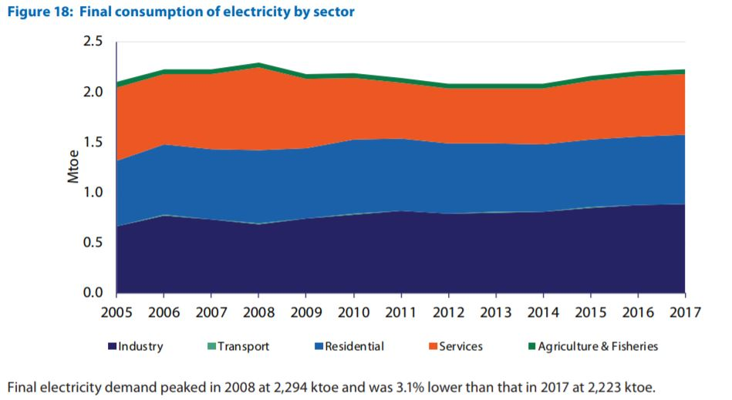

**Figure 9:Figure adapted from [2]**

“For the period 2009-10, domestic customers account for 91% of connections in Ireland and Northern Ireland. For the island as a whole, there are approximately 2.77 million customer connections, which illustrate the potential for energy management products and services in the home.”

**2.4 Category Strategy**

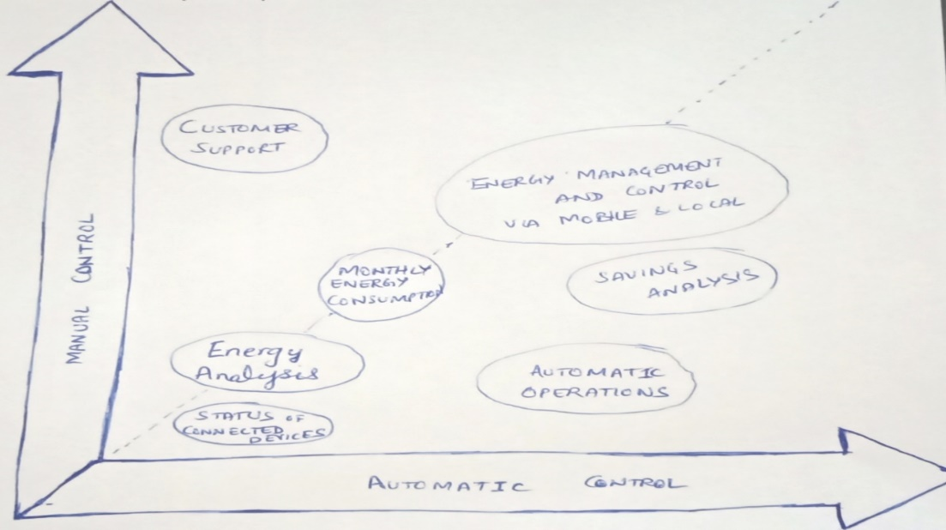

**Figure 10: Category Strategy Diagram**

* Energy Management and Control for Domestic, Commercial and Public Customers.
* I have chosen two market drivers’ Manual operation and Control in case of Emergencies and Automatic Operation and Control in regular conditions.
* The manual operation for the Energy Consumption, analysis and control is already available and does not make much difference while driving market. The automatic operation, analysis and control with a lot of customizable operations would assist customers better monitor and control of their home and workspace reducing extra efforts.
* Customer suggestions, responses and analysis based on service will assist in driving market in a fast-paced energy market.

**2.5 Customers**

My first targeted customers are Domestic and small venture customers who utilises Energy Management Solutions rarely.

Home Owners, Retailers, Stores, shops, Malls, small organisations, institutions etc. every property is being electrified and is fitted with large number of electronic and electrical devicesbased on sensors. All these customers require energy management solutions at moderate prices and with good quality.

A survey and market testing of the product and service before launch will give a clear idea of people interest and services required by them.

**2.6 My unique selling point**

My unique selling point would be the ability of controlling all devices from webpage so that anyone who is ill, disabled or at old age would be able to manage devices with ease while saving electricity by unplugging devices that are not in current use anytime.

Below fishbone figure shows the Sails sectors of various market categories and drivers that would help influencing business growth rate.

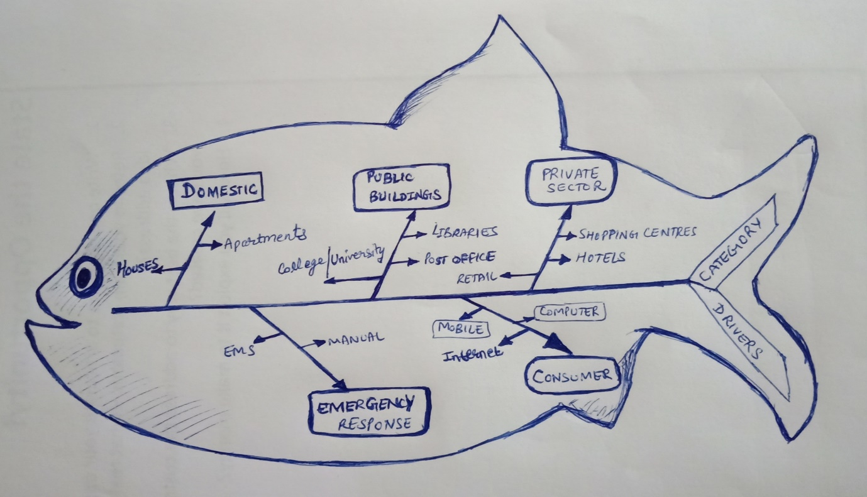

**Figure 11: Fishbone Diagram**

**Adapted from [1]**

The following segment strawman figure shows details of definer, descriptor, content, context and compatibility categories.

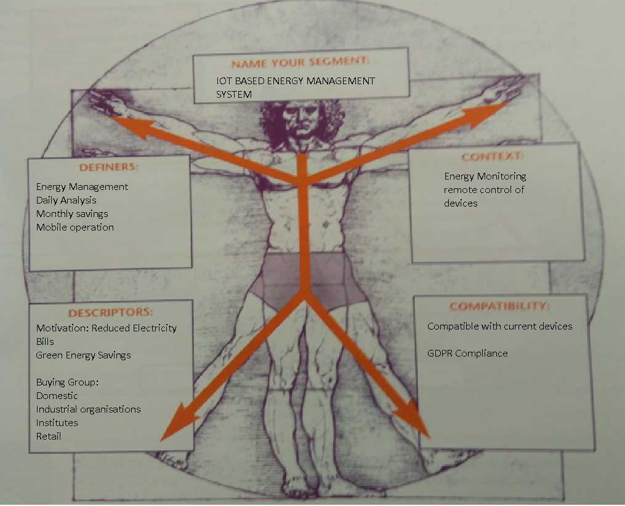

**Figure12:Segment Strawman**

**Adapted from [1]**

**Typical Targeted Customer Questionnaire**

|  |  |
| --- | --- |
| 1. **Who does the customer purchase when making this type of buying decision.?** | New technology  Best in budget  Sustainable  Longevity of product and service |
| 1. **How much money do you think the customer would be willing to spend on your product?** | Customers will willingly pay for initial cost if the service will save significant money from their income |
| 1. **Does the customer see this as a capital investment or operating expense?** | Customers would see the service as an operating expense |
| 1. **How would your products be evaluated? Who would evaluate them?** | Domestic Customers would evaluate the service by providing feedback and ratings |
| 1. **How long does the purchase process take?** | Purchase process would take minimum 24 hours for installation of the hybrid service |
| 1. **What are the two or three benefits that the customer could say ‘no’ to?** | Ease and control of the electric devices within seconds without any physical movement;  Energy savings and reduced bills |
| 1. **Are any certifications or approvals required before the customer can purchase your product?** | There is no certification required for the purchase of the service;  Organisation would handle all the formalities |
| 1. **Is your customer a risk-taker, an innovator or a more conservative buyer?** | Domestic Customers are conservative and innovators |

**2.7 Competitors**

The major Organisations in energy industry are C3 Energy, Delta Electronics Inc., General Electric Company, GrindPoint Inc., Honeywell International Inc., Schneider Electric S.E., Siemens AG, and Yokogawa Electric Corporation. The strategies adopted by these organisations are Product launching techniques, analysis and acquisition, and collaboration with various local partners. This has resulted in successful establishment of these companies in the market.

**Major Market Players in Commercial Sector**

* C3 Energy
* Delta Electronics, Inc.
* General Electric Company
* Honeywell International Inc.
* Johnson Controls International PLC
* Schneider Electric S.E.
* Siemens AG
* Yokogawa Electric Corporation
* DEXMA
* GridPoint Inc.

Based on Internet of Things technologies there are two major players who are already working on projects for targeting domestic users and building plans to expand their feet into the home energy management system market.

|  |  |  |
| --- | --- | --- |
| **Competitor** | **Strengths** | **Weaknesses** |
| **Major Competitor 1** | * Schneider Electric | * Target bigger customers * Monitoring system only. * Their products can be used with devices. |
| **Major Competitor 2** | * Thing Worx | * Target bigger industries. * Still under Research for services. |

**2.8 Promotion**

|  |  |  |  |
| --- | --- | --- | --- |
| **Promotional method** | **How** | **When** | **Cost** |
| Word of mouth | Institutions, Public places, door to door advertising | Initial stage | 2000€ |
| Digital Media, Newspapers | Social network such as Facebook, twitter, Instagram,  Magazines and newspapers | After success of initial stage | 5000€ |
| Television/Radio | Short Adverts during Live Matches, Popular TV series, Netflix etc | After Popularity | 10000€ |
|  |  |  | **Total: €17000** |

**2.9 Place/channels of distribution**

The Product/service will be Transported via local transportation techniques by Servicing and Delivery Vehicles. The Product will be stored in Company’s premises.

**3. Intellectual Property**

* Have you legally protected your Product/Service to date? Yes / No

If yes, please describe:

**NO. The idea has not been protected till date legally.**

* Are you aware of any other Patents, trademarks or copyright issues with your product? If so describe

**Not applicable.**

**4. People**

**4.1 Potential for employment in Ireland in this company**

Manpower plays crucial role in development of Business. The Success of this idea will create more employment since its development stage and will provide thousands of Jobs once get popularity among consumers of Ireland.

**5. Finance**

**The Financial statement is predicted for overall setup of business within a year. It is crucial to note that the figures tend to change with the change in currency due to global economic changes.**

**5.1 Capital costs**

|  |  |
| --- | --- |
| **Capital items required** | **Value €** |
| **Equipment/tools**  **Fixtures & fittings**  **Vehicle**  **Security & safety**  **ICT**  **Office Furniture**  **Kitchen** | **1000**  **1000**  **1000**  **500**  **500**  **1000**  **NA** |
| **Total** | **€5000** |

**5.2 Variable costs**

|  |  |
| --- | --- |
| **Variable costs e.g. stock, materials** | **Costs per annum** |
| **Insert type of variable cost – Part time Workers** | **2000** |
| **Insert type of variable cost – Local Advertisers** | **5000** |
| **Insert type of variable cost** |  |
| **Total variable costs** | **€ 7000** |

**5.3 Fixed costs**

|  |  |
| --- | --- |
| **Fixed costs** | **€** |
| **Rent & rates** | **10000** |
| **Heat & power** | **5000** |
| **Tel & internet** | **1000** |
| **Vehicle expenses** | **2000** |
| **Advertising & promotion** | **10000** |
| **Office supplies and postage** | **3000** |
| **Sundries** | **NA** |
| **Accountancy & legal** | **5000** |
| **Insurance** | **5000** |
| **Sundries** | **NA** |
| **Staff costs** | **50000** |
| **Finance charges** | **8000** |
| **Drawings** | **5000** |
| **NIC (Class II)** | **1000** |
| **Other __________** |  |
| **Other _________** |  |
| **Other _________** |  |
| **Total** | **€105000** |

**5.4 Pricing**

**Set Price of your product here that how much cost you want to set.**

The price of installation and initial service for the purchase of the service product will be €250.

**5.5 Sales (monthly sales projections for the first 12 months of business trading.)**

|  |  |  |  |  |  |  |  |  |  |  |  |  |  |
| --- | --- | --- | --- | --- | --- | --- | --- | --- | --- | --- | --- | --- | --- |
| **Month** | **1** | | **2** | | **3** | | **4** | | **5** | | **6** | | |
| **Sales €** | **10000** | | **30000** | | **50000** | | **60000** | | **70000** | | **75000** | | |
| **Month** | | **7** | | **8** | | **9** | | **10** | | **11** | | **12** | **Total** |
| **Sales €** | | **80000** | | **85000** | | **90000** | | **100000** | | **120000** | | **130000** | **150000** |

**5.6 Sales assumptions**

* Product and Service demand is increasing on daily basis in residential and industrial consumers.
* People are liking our product and services and interested in buying our services.

**5.7 Funding**

|  |  |  |  |
| --- | --- | --- | --- |
| **Project Costs** | **€** | **Sources of Funding** | **€** |
| **Estimated** | **1,00,000-1,30,000** | **Promoter** | **10000** |
|  |  | **Family/Friends** | **5000** |
|  |  | **Banks** | **50000** |
|  |  | **Venture Capitalists** | **50000** |
|  |  | **Other:** | **10000** |
|  |  |  | **1,25,000** |

**5.8 Exports**

If the Product get success in Ireland, there is definitely strong potential of growth of service in Europe and worldwide in developing and developed nations. The initial start-up is a biggest challenge that is common for any new business launch. Once it will make its brand name and setup a benchmark as a new innovation in market and acceptance by customers would surely boom the business potential of this suggested hybrid service across the globe.

**References**

[1]Google Books. (2019). *So What? who Cares? why You?*. [online] Available at: https://books.google.ie/books/about/So_What_who_Cares_why_You.html?id=PFxqFrvScwAC&redir_esc=y [Accessed 28 Apr. 2019].

[2]Seai.ie. (2019). [online] Available at: https://www.seai.ie/resources/publications/Energy-in-Ireland-2018.pdf [Accessed 28 Apr. 2019].

[3]Intertradeireland.com.(2019). [online] Available at: https://intertradeireland.com/insights/publications/market-report-on-the-energy-management-sector/?download=file&file=355 [Accessed 28 Apr. 2019].

[4]Qph.fs.quoracdn.net. (2019). [online] Available at: https://qph.fs.quoracdn.net/main-qimg-b66231fd9d40cfad43549ae8e57bc6a6 [Accessed 28 Apr. 2019].

[5]*Knowledge.energyinst.org*, 2019. [Online]. Available: https://knowledge.energyinst.org/__data/assets/pdf_file/0010/198739/Energy-Essentials-A-guide-to-energy-management.pdf. [Accessed: 10- May- 2019].

[6]"Energy Management Systems (EMS) Market Size, Share and Analysis | 2023", *Alliedmarketresearch.com*, 2019. [Online]. Available: https://www.alliedmarketresearch.com/energy-management-systems-market. [Accessed: 12- May- 2019].

[7]2019. [Online]. Available: https://www.researchgate.net/figure/Developed-hardware-and-software-as-part-of-a-smart-home-energy-management-system_fig2_284031910. [Accessed: 15- May- 2019].